Traffic Simulating System
Software Requirements Specification

Version 1.0
Revision History
Date | Version | Description | Author
05/Oct/2008 | 1.0 | SRS draft | Mohan Yang

Table of Contents
1. Introduction 4
1.1 Purpose 4
1.2 Scope 4
1.3 References 4
2. Overall Description 4
2.1 Use-Case Model Survey 4
3. Specific Requirements 5
3.1 Use-Case Reports 5
3.2 Supplementary Requirements 6
4. Supporting Information 6

Software Requirements Specification

Introduction

Purpose
The purpose of this document is to define requirements of the traffic simulating system. This software requirements specification lists the main use case of the traffic simulating.

Scope
This software requirements specification applies to the traffic simulating system which will be developed by the 06ACM traffic simulating system developing team. The traffic simulating system will enable city planners simulating the real traffic situation after road designing.

References
Applicable references are:
1. Vision Document of the traffic simulating system, V1.1, 2008, 06 ACM Honored Class.

Overall Description

Use-Case Model Survey
a) Use case diagram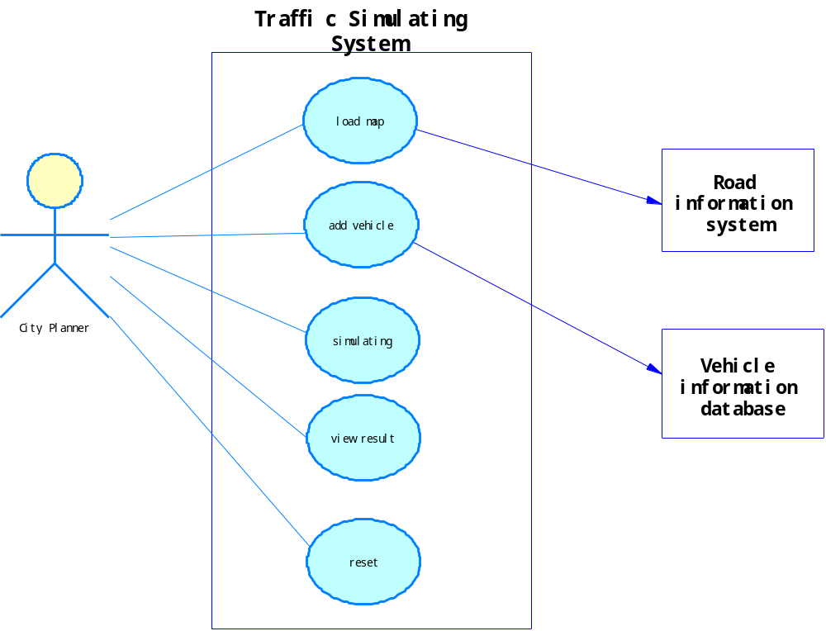

b) Use-Case Survey
Name | Description | Priority
load map | Load map from road information system | H
traffic light/load map | Control traffic situation | M
add vehicle | Add vehicle supported by vehicle information system by specialized script | H
simulating | Kernel of the system, simulating the results | H
car simulating/simulating | Perform the behavior of car from the start point to the end point | H
accident handle/simulating | Handle traffic accident when it happens | M
view result | View simulating result | H
map rotate/zoom/ view result | Through rotating/zooming, view any detail of the map | L
view statistics/view result | View statistics of the simulating, such as number of cars passing a cross. | H
reset | Reset the system to initial state | L
vehicle track/simulating | Tracking the movement of a specific vehicle | E
design road/load map | Specify properties of roads | E
Note1. H means high priority, M means medium priority, L means low priority and E means extendable use case.
Note2. X1/X2 means use case X1 is a sub use case of use case X2.

Specific Requirements

Use-Case Reports
name | responsible developer
load map | Mohan Yang
add vehicle | Liangda Li
car simulating | Sangxia Huang
view statistics | Xiangru Chen

Supplementary Requirements

Supporting Information
See Glossary.

